11/1/2019

BEEE LAB

Experiment-2-Door Bell

Name : Nishant.C

Course: Btech(CSE)

Sec :CSE-iOT-1 GRP-A

UID : 19BCS4526

**Door Bell**

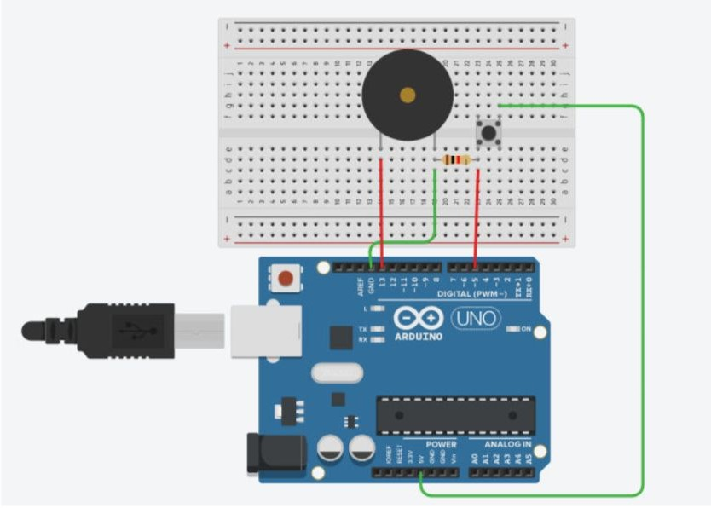

# Concept Used :-

This Experiment shows the working of Doorbell using Buzzer by Arduino.A circuit consists of 2 digital pins are used where a pin i.e., 7 making connection of buzzer with Arduino and further making the connection to the ground. Now another pin i.e., 12 is connected to switch. One end of the switch is connected to 5V supply and intersection of pin 12 and switch is connected to resistor which is connected to ground from another end

Value of resistance is very high. The resistors are used to resist the flow of current. Coding is done in such a way that when switch is pressed the buzzer starts making sound and again when switch is pressed buzzer do not make any sound.

# Learning and Observations : -

1. Basic understanding of the electrical connection.
2. Making circuits using Arduino.
3. Connecting buzzer and switch with arduino.
4. Ground has least resistance.
5. Working of Arduino UNO.
6. Coding to be done on Arduino.exe for stimulation of the experiment.
7. How does Toggling works.

# Problems & Troubleshooting: –

No problem occurred during the execution of the experiment.

# Precautions :-

* 1. Making Correct connection.
  2. Using Multimeter to check whether all the devices are in working condition or not.
  3. Correct sets of instructions are provided or not to perform the specific function
  4. Port Selection for Arduino can be incorrect due to which it won’t upload on

# Learning Outcomes: –

1. Setting up correct connections to the arduino.
2. Connecting switch, buzzer and Arduino.
3. Using switch and buzzer.
4. Working and coding of Arduino.

# Result: –

Working of buzzer and switch verified after uploading the program. Doorbell is ready to ring.